
CATHOLIC JUNIOR COLLEGE
H
Preliminary Examination 2010
Higher 2

CANDIDATE
NAME
CLASS
2
T

CHEMISTRY 9647

Paper 3 Free Response Questions 2 September 2010
2 hr
Additional Materials: Data Booklet
Writing Paper

READ THESE INSTRUCTIONS CAREFULLY
Write your name and class on all the work you hand in.
Write in dark blue or black pen on both sides of the paper.
You may use a soft pencil for any diagrams, graphs or rough working.
Do not use staples, paper clips, highlighters, glue or correction fluid.

Answer any four questions, on the writing paper provided.
A Data Booklet is provided.
You are reminded of the need for good English and clear presentation in your answers.

The number of marks is given in brackets [ ] at the end of each question or part question.
At the end of the examination, detach this cover sheet and fasten it together with all the answer scripts of this paper securely together.
For Examiner’s Use
Q 1
Q 2
Q 3
Q 4
Q 5
80


This document consists of 7 printed pages and 1 blank page.

CJC Chemistry Department

© CJC 2010
1 (a) The first ionisation energy of aluminium is 577 kJ mol⁻¹, while that of magnesium is 736 kJ mol⁻¹. Explain this observation. [2]

Mg 1s² 2s² 2p⁶ 3s² Al 1s² 2s² 2p⁶ 3s² 3p¹
• Lower 1st I.E. of Al because less energy is needed to remove a 3p electron in Al than a 3s electron in Mg since the 3p electron is further away from the nucleus and it also experiences slightly better shielding (from the 3s electrons).

(b) When pure aluminium is left in air, it forms a protective coating. When this piece of aluminium is then placed in dilute hydrochloric acid or sodium hydroxide, initially there is no observable reaction but, after a few minutes, a colourless gas is evolved.
(i) Identify the protective coating and explain the observation as fully as you can. Write balanced equations for all reactions that occurred.

• protective coating is Al₂O₃
which is amphoteric and so, is removed by dilute HCl or NaOH(aq).
Al₂O₃ + 6HCl → 2AlCl₃ + 3H₂O
Al₂O₃ + 2NaOH + 3H₂O → 2NaAl(OH)₄

• pure Al would then react with dilute HCl or NaOH(aq) to give
effervescence of H₂(g), a colourless gas.
2Al + 6HCl → 2AlCl₃ + 3H₂
2Al + 2NaOH + 6H₂O → 2NaAl(OH)₄ + 3H₂
[or 2Al + 6NaOH → 2Na₃AlO₃ + 3H₂ or 2Al + 2NaOH + 2H₂O → 2NaAlO₂ + 3H₂]

(ii) Hence suggest why solid formulations of drain cleaners are mostly made out of strong alkalis to which aluminium has been added.
[6]
• The formation of H₂(g) leads to a bubbling effect which provides an additional mechanical cleaning mechanism.

(c) One of the products formed in (b) is used in the chlorination of methylbenzene. Identify this compound. Outline the mechanism for the chlorination of methylbenzene, showing clearly the role of this compound in the mechanism. [5]

• AlCl₃ – functions as catalyst / halogen-carrier.
• electrophilic substitution
Cl₂ + AlCl₃ → Cl⁺ + AlCl₄–
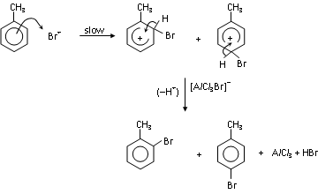
Cl⁺
Cl
Cl
Cl
Cl
HCl
AlCl₄–

(d) Recent studies are carried out to explore the use of (4-aminophenyl)ethanoic acid
(4-APEA) and its derivatives as possible drugs to treat chronic inflammation of the intestines. 4-APEA may be synthesised from methylbenzene as follows.
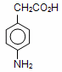
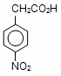
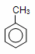
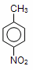
A
I
B
II
III
4-APEA

Draw the structural formulae of intermediate compounds A and B, and state clearly the reagents and conditions used in each of the stages I, II and III in the above synthesis of 4-APEA. [5]

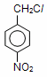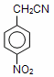• A is B is

• stage I: Cl₂ or Br₂, uv light
• stage II: ethanolic KCN, heat or reflux
• stage III: dilute H₂SO₄, heat or reflux

(e) Oil spills are a waste of valuable resources and cause environmental problems. Traditional sorbent materials also absorb water in addition to oil, and as a result are unable to stay afloat. However, a new sorbent material called ‘hydrophobic aerogels’ has been developed to solve this problem. Due to its fluorine-containing groups, this new material is able to allow oil to be absorbed but not water.
––O––Si––CH₂––CF₃
By considering interactions between molecules, suggest why the ‘hydrophobic aerogels’ absorb oil but not water. [2]
[Total: 20]
• hydrophobic gels form van der Waals forces of attraction with oil molecules
• but cannot form hydrogen bonds with water molecules.

- Potassium iodide and hydrogen peroxide have similar reducing properties.

(a) An aqueous solution containing 0.005 mol of bromine was added to 10.00 cm³ of
0.10 mol dm⁻³ sodium thiosulfate. 0.002 mol of potassium iodide was then added to the resulting solution to completely remove the unreacted bromine.

(i) Write an ionic equation for the reaction between potassium iodide and bromine.

Br₂ +2I⁻ → I₂ + 2Br –

- Calculate the number of moles of bromine which react with 1 mol of sodium thiosulfate.
no. of moles of excess Br₂ that reacted with potassium iodide = 0.002 / 2 = 0.001 mol
no. of moles of Br₂ that reacted =0.005- 0.001 = 0.004 mol
no. of moles of S₂O₃²⁻ = (0.01)(0.10) = 0.001 mol
no. of moles of Br₂ reacted with 1 mole of S₂O₃²⁻ = 0.004 / 0.001 = 4 mol
[4]

(b) The decomposition of hydrogen peroxide to form water and oxygen follows first order kinetics. It was found that a certain solution of hydrogen peroxide undergoes complete decomposition to liberate 96 cm³ of oxygen gas.

(i) Given that 48 cm³ of oxygen gas was collected in 46 minutes, calculate the time taken for 72 cm³ of the gas to be evolved. (All volumes of oxygen gas are measured at the same temperature and pressure).

2H₂O₂ → 2H₂O + O₂
The half-life of the reaction, t is 46 minutes (2760s).
Two half-lives would have elapsed when the total volume of gas collected is 72 cm³.
Time taken = 46 x 2 = 92 minutes.

- Find the rate constant, k, for the reaction.

k = ln 2 / t = ln 2 / 46 = 0.0151 min⁻¹ or 2.51 x 10⁻⁴ s⁻¹
[3]

- The reaction between 2-bromobutane and aqueous sodium hydroxide when heated under reflux is represented by the equation below.

CH₃CHBrCH₂CH₃ + OH– → CH₃CH(OH)CH₂CH₃ + Br –

Experiments were conducted by mixing varying concentrations of the reactants. The results are given in the table below.

Experiment | [CH₃CHBrCH₂CH₃]  / mol dm⁻³ | [OH–]  / mol dm⁻³ | Initial rate of reaction  / mol dm⁻³ min⁻¹
1 | 0.0012 | 0.10 | 0.024
2 | 0.0030 | 0.10 | 0.060
3 | 0.0072 | 0.60 | 0.144

- Determine the order of reaction with respect to 2-bromobutane and sodium hydroxide. Hence, state the rate equation.

Comparing experiments 1 & 2, when [2-bromobutane] was increased by 2.5 times, initial rate also increased by 2.5 times. Hence, rate α [2-bromobutane], order of reaction wrt 2-bromobutane = 1.

Comparing experiments 1 & 3, both [2-bromobutane] & [OH–] were increased by 6 times & initial rate increased by only 6 times. Since order of reaction wrt 2-bromobutane is already found to be 1, the increase in rate was due to the increase in [2-bromobutane] while increase in [OH–] has no effect on rate. Hence, order of reaction wrt NaOH = 0
OR
Comparing experiment 1 and 3, Rate = [2-bromobutane]^{m}[OH⁻]^{n}

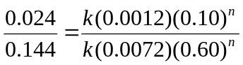
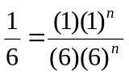
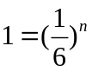
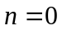

Hence, order of reaction wrt NaOH = 0

Rate = k [2-bromobutane]

- Calculate the rate constant, stating the units clearly.

k = 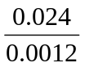 = 20 min⁻¹

- Describe the type of mechanism involved.

Nucleophilic substitution (S_{N}1)

Step 1:

Step 2:
OH–
fast
CH₂CH₃
H
CH₃
⊕
C
CH₂CH₃
CH₃
HO—C
H
δ-
slow
+ Br–
CH₂CH₃
H
C—Br
CH₃
δ+δ–
CH₂CH₃
H
CH₃
⊕
C

[8]

- Another experiment is carried out using 2-bromobutane and ethanolic sodium hydroxide. State the type of reaction that would occur and draw the structures of all the possible organic products formed, including stereoisomers. [3]

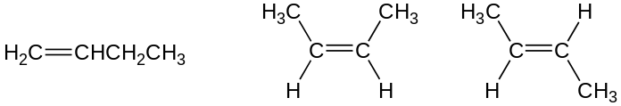

- Describe a chemical test to distinguish between 2-bromobutane and bromobenzene.
[2]
Reagents: Aq. / Ethanolic Silver nitrate, AgNO₃
Conditions: Heat
Observations: A cream precipitate will be observed for 2-bromobutane whereas no precipitate will be observed for bromobenzene.
[Total: 20]
- Use of the Data Booklet is relevant to this question.

Water containing iron(II) compounds is known as ‘clear water’ because it appears colourless. However, when water seeps through iron-bearing soil or passes through corroded iron water pipes, it may become coloured. ‘Red water’ refers to water containing iron(III) compounds.

When ‘red water’ is used in laundry, iron stains can be formed on clothes.

(a) Explain why iron(III) compounds are coloured. [3]

When ligands are attached to the centre metal ion, they will cause the degenerate d-orbitals to split into 2 energy levels.
The d orbitals are partially filled. When electron from the lower d-orbitals absorbs energy in the visible light region, it will be excited to the higher d* orbital. Such transition is d-d* electronic transition.
Complementary colours which are not absorbed will the reflected as the colour of the compound.

(b) The standard electrode potential of the Fe³⁺(aq)/Fe²⁺(aq) half-cell relative to the standard hydrogen electrode is 0.77 V. Predict, with reasons, how the electrode potential will change if the following are added to the Fe³⁺(aq)/Fe²⁺(aq) half-cell:
(i) ‘red water’
E _{Fe3+ / Fe2+} will increase / more positive
Fe³⁺ + e⁻ Fe²⁺
Addition of red water will increase [Fe³⁺].
By LCP, position of equilibrium will shift to the right or more [Fe²⁺] is produced.

(ii) pure water
E_{Fe3+ / Fe2+} will not change
Addition of pure water will decrease [Fe³⁺] and [Fe²⁺] to the same extent

[4]

- Explain the following observations, giving relevant equations:

- When ‘red water’ is added to aqueous KI, the solution turns brown.

E^{ө}_{I2 / I−} = +0.54 V
E^{ө} = 0.77 - 0.54 >0 or E^{ө}_{Fe3+ / Fe2+} is more positive than E^{ө}_{I2 / I−} or I⁻ is oxidized by Fe³⁺ to I₂
2Fe³⁺ + 2I⁻ → 2Fe²⁺ + I₂

- When ‘red water’ is first added to aqueous KCN, a ligand replacement reaction takes place and an orange solution is formed. Upon the addition of aqueous KI, the orange solution remains.

[Fe(H₂O)₆]³⁺ + 6CN⁻ [Fe(CN)₆]³⁻ + 6H₂O

E^{ө} = 0.36 - 0.54 < 0
or E^{ө} _{[Fe(CN)6]3− / [Fe(CN)6]4−} is less positive than E^{ө}_{I2 / I−}
or I⁻ is a weaker ligand than CN⁻, ligand replacement cannot occur

[4]

(d) Stain removers containing reducing agents can be used to remove iron stains caused by ‘red water’.

- Explain, with the use of E^{ө} values, why sodium ethanedioate is effective in removing iron stains under standard conditions. Hence, write the balanced equation for the reaction involved.

The standard redox potential for the half cell reaction is

2CO₂ (aq) + 2e⁻ C₂O₄²⁻(aq) E^{ө} = -0.49 V

E^{ө} = 0.77 – (-0.49) = 1.26 >0 Reaction is spontaneous/feasible
2Fe³⁺ + C₂O₄²⁻ → 2CO₂ + 2Fe²⁺

- Suggest why sodium ethanedioate is preferred over ethanedioic acid as an iron stain remover.

Ethanedioic acid is a weak acid; partial dissociation of ethanedioic acid provides less [C₂O₄²⁻].

- Would you recommend stain removers containing hydrogen peroxide as effective iron stain removers under standard conditions? Explain.
E^{ө}_{O2 / H2O2} = +0.68 V
E^{ө} = 0.77 – (0.68) = 0.09
E^{ө} value is small; reaction will not go to completion, not effective
[5]

(e) Three unknown iron(III) complexes A, B and C with the general formula FeCl₃.6H₂O, in which the coordination number is 6, have been prepared.

When 0.01 mol of each complex is treated separately with aqueous silver nitrate, the following masses of white precipitate are obtained.

Complex | A | B | C
Mass of white precipitate formed / g | 4.30 | 1.44 | 1.44

(i) Deduce the structural formula of complex A.

Amt of AgCl = 4.30 / (108 + 35.5) = 0.0300 mol
Structural formula: [Fe(H₂O)₆] Cl₃

(ii) B and C are geometric isomers of each other. Using the information above, draw the structures of complexes B and C.
Amt of AgCl = 1.44 / (108 + 35.5) = 0.0100 mol
Structural formula: [Fe(H₂O)₄Cl₂] Cl

[4]
Fe
[Total: 20]
4 (a) Compounds F and G have the same molecular formula C₁₀H₁₁NO₂. Both compounds react with Tollens’ reagent, but only G reacts with Fehling’s solution.
The structure of G is:
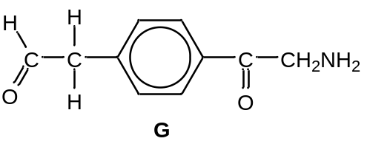

When F is heated with aqueous sodium hydroxide, compound H and gas I, which turns red litmus paper blue, is evolved. G reacts with excess chloromethane to form a salt J which can be isolated. J forms a white precipitate immediately on addition to aqueous silver nitrate.

When heated with acidified KMnO₄, H gives the acid L which has the structure shown below.

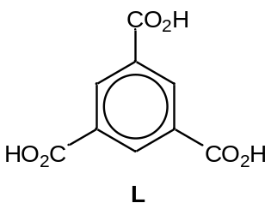

Deduce the identity of compounds F, H, I, J and explain the chemistry of the reactions involved.
[8]
Both compounds react with Tollen’s reagent → Both compounds contain an aldehyde
[1]
Gas turns red litmus paper blue: NH₃ (I) is released on heating with sodium hydroxide.

→ A primary amide (-CONH₂) is likely to be present. [1] G does not react with NaOH → absence of acid/ester/amide/phenol [1]
G can react with excess chloromethane to form a salt → G undergoes nucleophilic substitution with amine as the nucleophile to form a quarternary ammonium salt, J.
J: 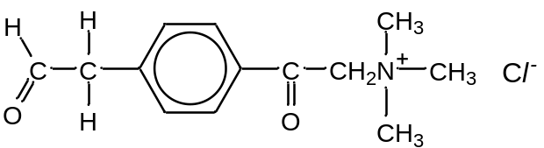
A white ppt of AgCl is formed immediately upon adding AgNO₃ as the salt can dissolve
in water to form Cl⁻ ions.
H undergoes side chain oxidation in acidified KMnO₄ to form L, indicating that F is a
trisubstituted benzene.
F: 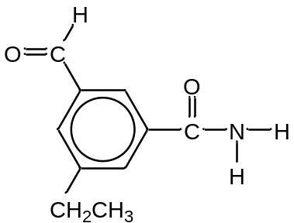 H: 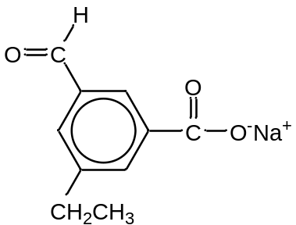

(b) Explain the difference in basicity between ethylamine, CH₃CH₂NH₂ and phenylamine, C₆H₅NH₂. [3]

Phenylamine is a weaker base than ethylamine.
The p-orbital of N overlaps with the π-electron cloud of the benzene ring in phenylamine. The lone pair on N is less available to accept a proton and thus is a weak base.
In ethylamine, the electron donating –CH₃ group increases the availability of lone pair on N to accept proton. Thus ethylamine is a stronger base than phenylamine.

OR

The electron donating –CH₃ group disperses the positive charge on N of CH₃NH₃⁺ while the electron withdrawing benzene ring intensifies the negative charge on N of C₆H₅NH₃⁺ , making it less stable than CH₃NH₃⁺. Phenylamine is thus a weaker base than ethylamine.

(c) The hormone insulin is responsible for regulating the blood glucose level in our body. Insulin consists of two polypeptide chains, which are made up of 21 and 30 amino acid residues respectively. Each chain coils to form short sections of alpha helix and the two chains are held together mainly by the interactions formed between the cysteine residues.

- Give the name and displayed formula of the linkage between amino acid residues in insulin.

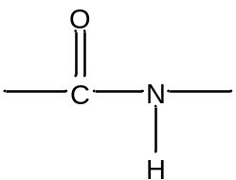
Peptide or amide linkage

- Describe how the polypeptide chain is held in the structure of an alpha helix.

The chain is held in a helix by hydrogen bonds formed between the C=O and
N-H of the peptide bonds within the chain.

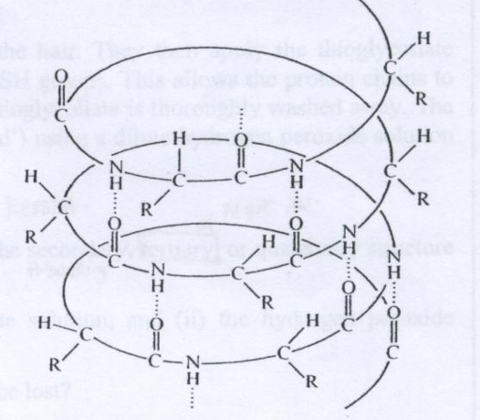
Hydrogen bond
OR Draw and label hydrogen bond

- The R-group of cysteine is (-CH₂SH). Illustrate the interaction formed between cysteine residues.

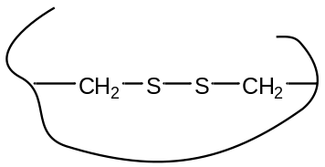

- Suggest how the addition of heavy metal ions can denature insulin.

Heavy metal ions can react with the –SH group to form strong metal sulfide bonds, preventing the formation of disulfide linkages.
[5]
(d) Another hormone, known as thyrotropin-releasing hormone (TRH), is a tripeptide with the following structure:
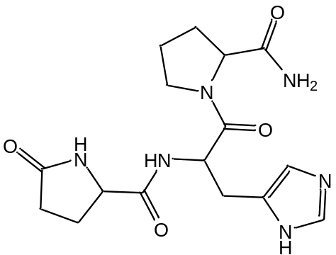
TRH
State the reagents and conditions required for the hydrolysis of this hormone into its constituent amino acids and give the structures of the three amino acids formed from its hydrolysis. [4]
Dilute HCl or NaOH, heat

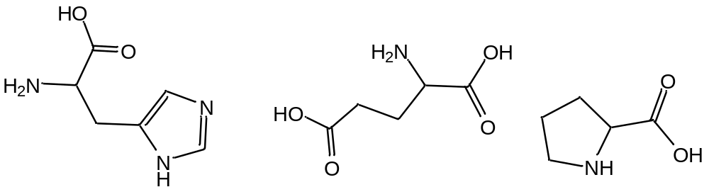
[Total: 20]
5 (a) In the preparation of iodoethane from ethanol, a student attempted to use concentrated nitric acid and solid potassium iodide to prepare the required reagent, hydrogen iodide, HI. During the experiment, he observed some formation of black precipitate and brown gas, NO₂, with a very low yield of HI formed, the other final product being water.

(i) Identify the black precipitate and suggest two balanced equations for the reaction of concentrated nitric acid with potassium iodide.

KI+ HNO₃→ HI + KNO₃; I⁻+ HNO₃→ HI + NO₃⁻
2HNO₃ + 2HI → I₂ + 2NO₂ + 2H₂O
Black precipitate: Iodine

(ii) In an attempt to increase the yield of HI, the student added more concentrated nitric acid to the black precipitate. However, this resulted in the formation of iodic acid, HIO₃, with more brown gas, NO₂, and water produced.

Suggest a balanced equation for this reaction and state the type of reaction.

10HNO₃ + I₂ → 2HIO₃ + 10NO₂ + 4H₂O
Redox reaction

(iii) Suggest an alternative set of chemicals that is suitable for the synthesis of iodoethane from ethanol.

Potassium iodide and concentrated Phosphoric (V) acid; KI+ H₃PO₄
OR Iodine and Red phosphorus; I₂ + P or PI₃

(iv) HI reacts fastest with alcohols, as compared to HBr and HCl, as iodide ion is the strongest nucleophile. Suggest why iodide ion is the strongest nucleophile.
[6]
Iodide has a larger anionic radius, hence a weaker attraction for the valence electrons, thus more likely to donate the electrons to the electron-poor site.

(b) IPA, Dettol and TCP are three hydroxy compounds often used as disinfectants and antiseptics.
 | 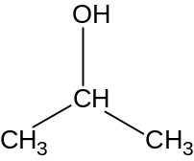 | 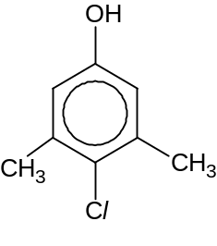 | 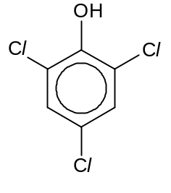
Common Name | IPA | Dettol | TCP
K_{a} / mol dm⁻³ | 7.94 x 10^{–18} | 1.99 x 10⁻¹⁰ | 6.46 x 10^{–7}

(i) Write a chemical equation to represent the acid dissociation of Dettol in water.
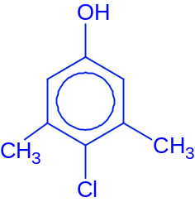 + H₂O ⇌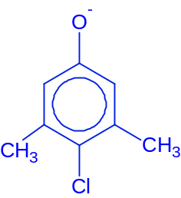+ H₃O⁺

(ii) Calculate the pH of 0.20 mol dm⁻³ of Dettol.
Let Dettol be HA,
HA ⇌ H⁺ + A⁻
Equilibrium 0.2 – x x x where [H⁺] = x
K_{a} = 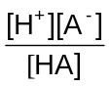=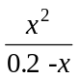
Assuming x is much smaller than 0.2,
1.99 x 10^{–10} = 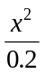
x = [H⁺] = 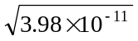= 6.31x 10⁻⁶ mol dm⁻³
pH = - log₁₀ (6.31 x 10⁻⁶) = 5.20

(iii) Compare and explain the relative acidity of IPA and Dettol.
Strength of acid: IPA < Dettol
IPA is less acidic than Dettol, as it has alkyl or methyl groups that are electron releasing and results in less polarised and stronger O-H bond. Hence the O-H bond is less likely to dissociate giving H⁺ ions.
Dettol is a stronger acid than IPA, as the lone pair of electrons on the oxygen atom can delocalize into the benzene ring, which results in more polarised and weaker O-H bond. Hence the O-H bond is more likely to dissociate giving H⁺ ions.
OR
the phenoxide formed is a more stable conjugate base due to the negative charge on the oxygen can be delocalised with in the ring.
Alkoxide formed is less stable as the negative charge is localised on the oxygen and intensified by the electron donating alkyl groups, thus more likely to susceptible to protons.
(iii) Explain why TCP is a stronger acid than Dettol.
TCP is a stronger acid than dettol, as it has more electron-withdrawing chlorine atoms substituent attached to the benzene ring, which results in a stronger electron-withdrawing effect and more polarised and weaker O-H bond
or more stable conjugate base, hence the H⁺ ions will be formed more easily.
[8]
(c) TCP can be made in the laboratory from phenol.

(i) State the reagents required, and give a balanced equation for this reaction.
Reagents: Aqueous Chlorine
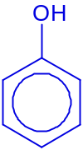 + 3Cl₂(aq) →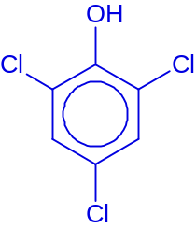+ 3HCl

(ii) Bottles of aqueous solutions containing IPA, Dettol and TCP were found without labels. Suggest a chemical test (stating reagents, conditions and observations) which can be used to distinguish the following pair of compounds:

I. TCP and Dettol

Reagents: Acidified Potassium Manganate (VII)
Conditions: Heat
Observations:
Purple KMnO₄ turns colourless with dettol, no such observation with TCP.

OR
Reagents: Aqueous Bromine
Conditions: Room temperature
Observations:
Orange\brown solution turns colourless with dettol and white misty fumes of HBr is released, no such observation with TCP.

II. IPA and Dettol [6]

Reagents: Iodine(aq) \ NaOH(aq)
Conditions: Warm
Observations:
Yellow ppt of triiodomethane, CHI₃ observed with IPA, no yellow ppt with dettol.

OR
Reagents: Acidified Potassium Dichromate
Conditions: Heat
Observations:
Orange K₂Cr₂O₇ turns green in colour with IPA, no such observation with dettol.

OR
Reagents: Aqueous Bromine
Conditions: Room temperature
Observations:
Orange\brown solution turns colourless with dettol and white misty fumes of HBr is released, no such observation with IPA.

OR
Reagents: neutral FeCl₃
Conditions: Room temperature
Observations:
Purple colouration formed with dettol but no such observation with IPA.

OR
Reagents: PCl₅
Conditions: Room temperature
Observations:
White misty fumes of HCl is formed with IPA but no such observation with dettol.

[6]
[Total: 20]

